Based on the provided code, answer the following multiple-choice questions:

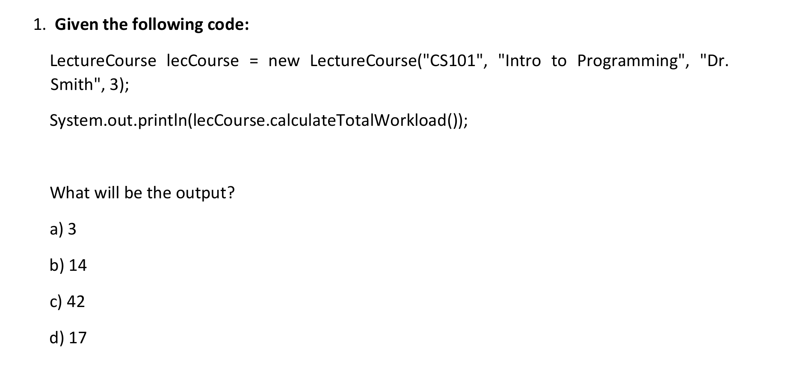
Ans: (c) 42

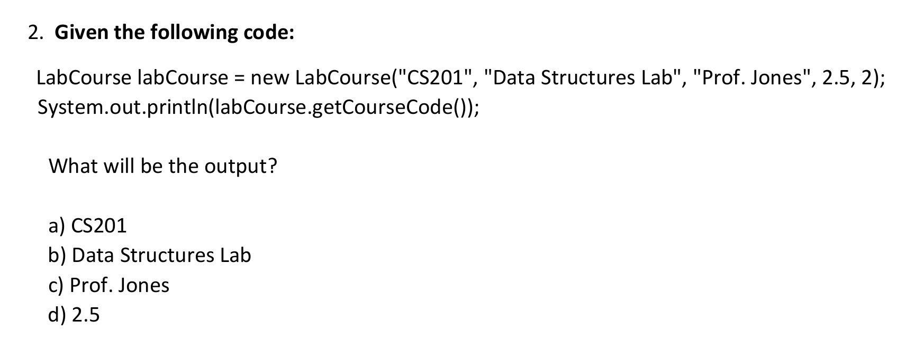
Ans: (a) CS201

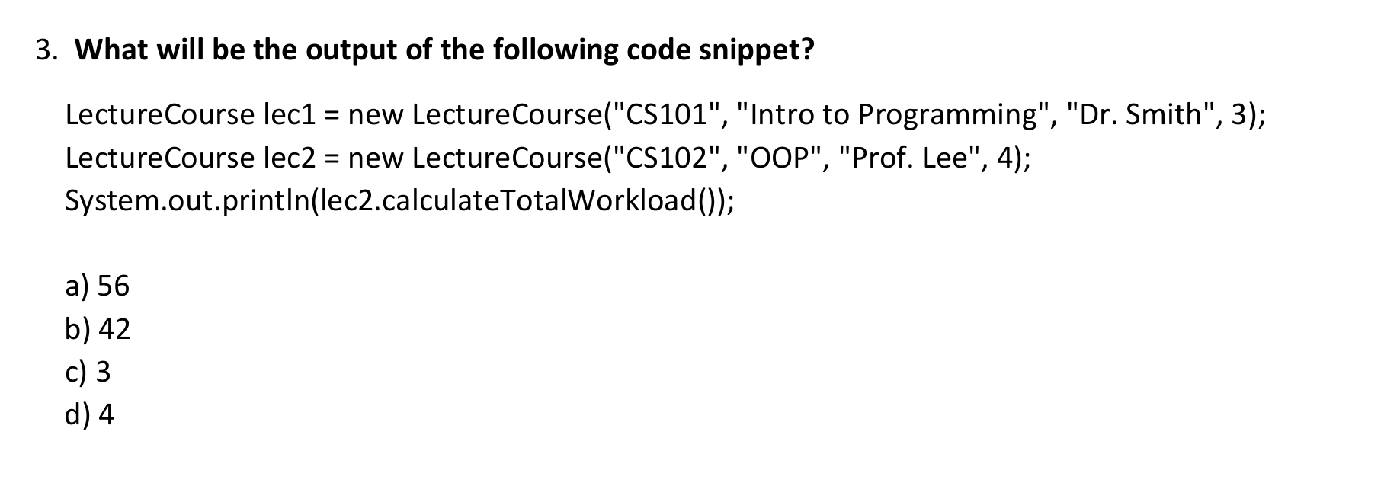
Ans: (a) 56

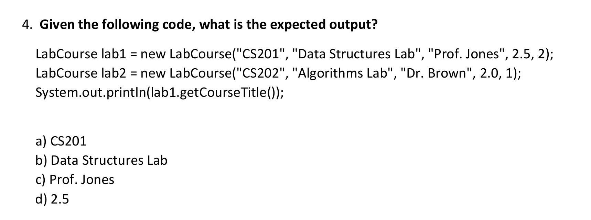
Ans: (b) Data Structures Lab

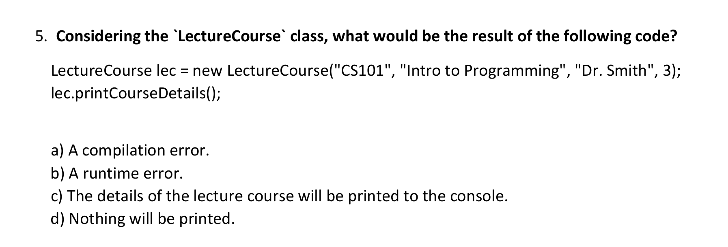
Ans: (c) The details of the lecture course will be printed to the console.

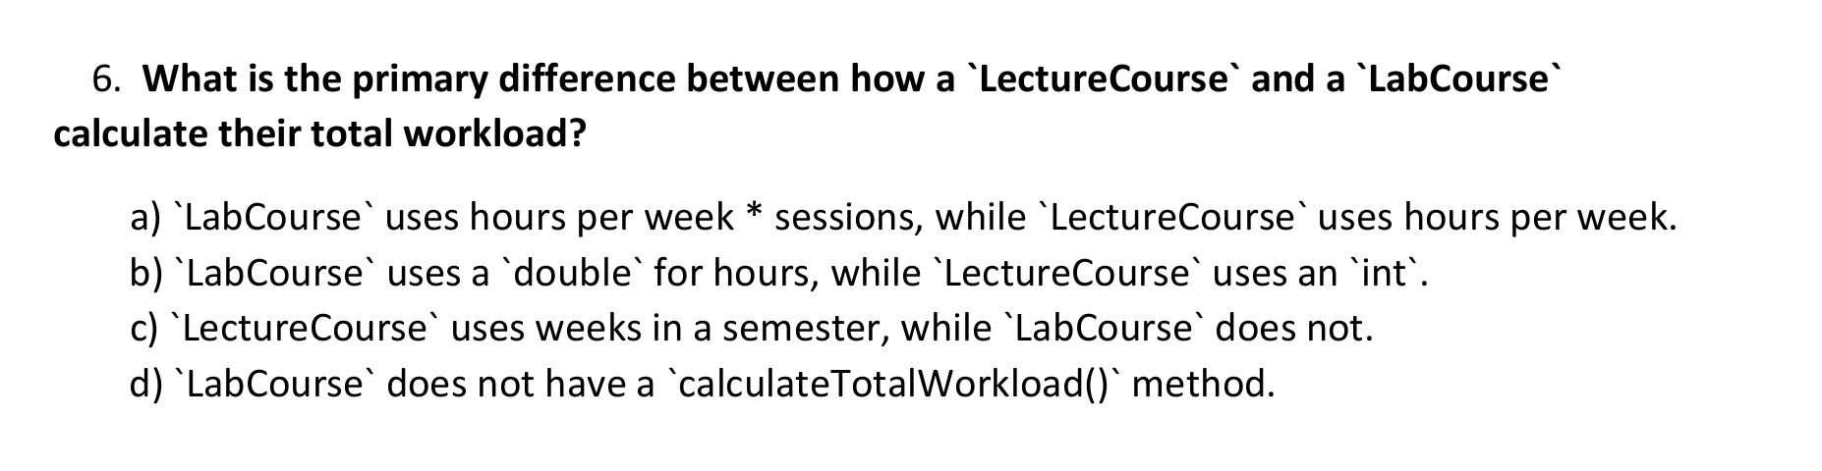
Ans: (a)

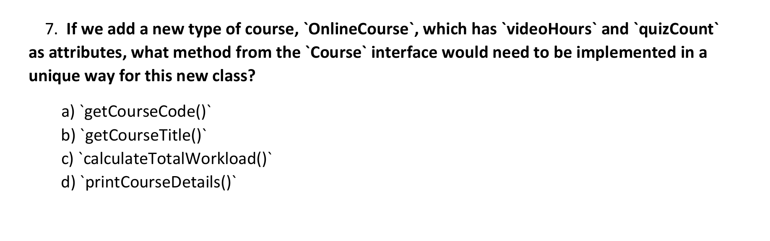
Ans: (c) `calculateTotalWorkload()`

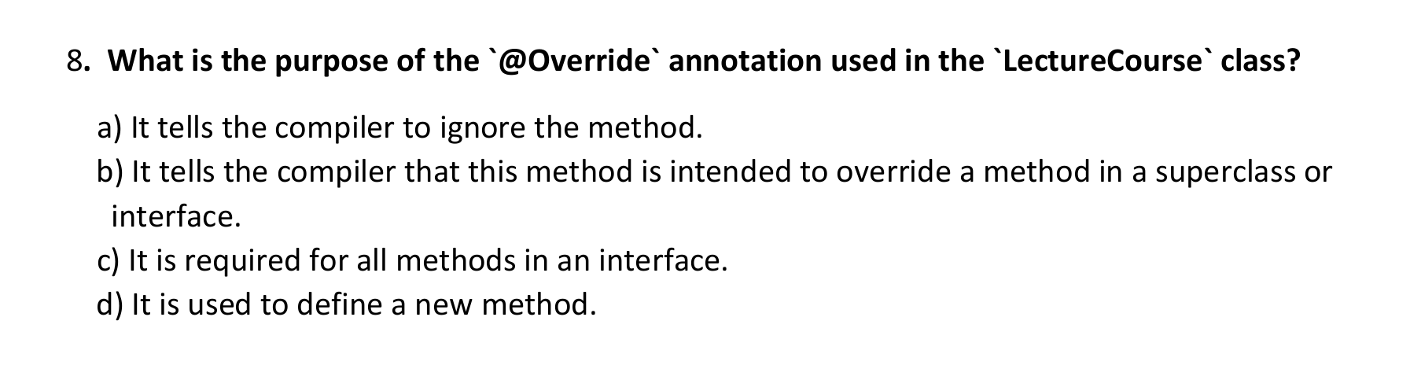
Ans: (b) It tells the compiler that this method is intended to override a method in a superclass or interface.

